**EXERCISE-17**

**PROCEDURES AND FUNCTIONS**

1. FACTORIAL OF A NUMBER USING FUNCTION

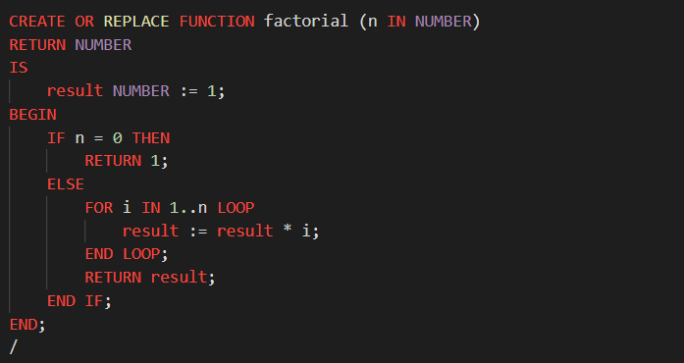

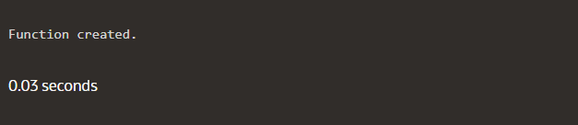

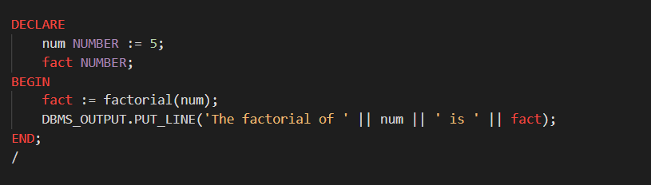

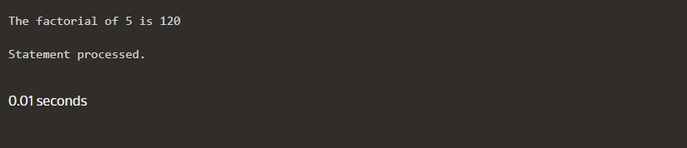

2. Write a PL/SQL program using Procedures IN,INOUT,OUT parameters to retrieve the corresponding book information in library

